

Tech Saksham

Case Study Report

Data Analytics with Power BI

# “ IPL Analysis Using Power BI”

**“A.G. Arts And Science college”**

|  |  |
| --- | --- |
| **NM ID** | **NAME** |
| 9190F55287F71268AEB420B7AFEF3D20 | CHANDRA KUMAR N |

|  |
| --- |
| Trainer Name **UMAMAHESWARI R** |
| Master Trainer **UMAMAHESWARI R** |

# ABSTRACT

In the era of digital entertainment, cricket franchises harness the power of data to thrive in the competitive landscape of the Indian Premier League (IPL). The proposed project, "Real-Time IPL Analysis " seeks to leverage Power BI, a premier business analytics tool, to dissect and visualize real- time IPL data streams. By utilizing this project, franchises aim to gain unparalleled insights into player performances, match trends, and fan engagement dynamics, empowering data-driven decision-making and elevating the IPL experience.

This project will revolutionize how IPL franchises strategize, market, and engage with fans by offering comprehensive insights into various facets of IPL matches. Through real-time analysis, franchises can swiftly adapt tactics, optimize player selections, and capitalize on emerging opportunities during matches. Additionally, the project will enable franchises to tailor marketing initiatives, merchandise offerings, and fan engagement activities to align with evolving fan preferences and behaviors.

By embracing digital innovation through this project, IPL franchises will not only enhance their on-field performance but also revolutionize fan experiences, bolster sponsorship opportunities, and drive revenue growth. This initiative aligns with the broader vision of digital transformation in the sports industry, fostering agility, innovation, and fan-centricity in the realm of IPL cricket.

**INDEX**

|  |  |  |
| --- | --- | --- |
| **Sr. No.** | **Table of Contents** | **Page No.** |
| 1 | Chapter 1: Introduction | 1 |
| 2 | Chapter 2: Services and Tools Required | 4 |
| 3 | Chapter 3: Project Architecture | 6 |
| 4 | Chapter 4: Modeling and Result | 7 |
| 5 | Conclusion | 11 |
| 6 | Future Scope | 12 |
| 7 | References | 13 |
| 8 | Links | 14 |

## CHAPTER 1 INTRODUCTION

### Problem Statement

In today's dynamic sports landscape, the Indian Premier League (IPL) stands out as a cornerstone of cricketing entertainment, captivating millions of fans worldwide. Yet, amidst the fervor of matches and player performances, cricket franchises grapple with extracting actionable insights from the deluge of IPL data. Traditional methods of data analysis prove inadequate in the face of the sheer volume, variety, and velocity of IPL data streams. Consequently, franchises encounter hurdles in deciphering real-time trends, player performance dynamics, audience engagement patterns, and strategic opportunities.

The absence of real-time analysis mechanisms hampers franchises' ability to swiftly adapt strategies, optimize team compositions, and capitalize on emerging trends during the IPL season. This lag in insights may lead to missed opportunities for talent scouting, sponsorship activation, fan engagement initiatives, and merchandise sales. Additionally, the multifaceted nature of IPL data, encompassing player statistics, match outcomes, social media sentiment, and viewer demographics, further complicates the analysis process.

Hence, the challenge at hand is to devise a robust data analysis framework powered by tools like Power BI to unlock actionable insights from IPL data swiftly. By overcoming the barriers of traditional analysis methods, cricket franchises can gain a competitive edge, enhance fan experiences, boost revenue streams, and fortify their position in the ever-evolving IPL ecosystem.

### Proposed Solution

The proposed solution is to develop a Power BI dashboard tailored for IPL analysis, capable of harnessing real-time match data. This dashboard will consolidate data from diverse sources, including match statistics, player performance metrics, social media sentiment, and viewer engagement metrics. By aggregating and visualizing this data

in an intuitive dashboard interface, stakeholders such as team management, sponsors, broadcasters, and fans will gain valuable insights into IPL dynamics.

The dashboard will offer interactive features, allowing users to explore trends, compare player statistics, track match outcomes, and monitor audience engagement in real-time. Its user-friendly design will enable stakeholders to customize views and drill down into specific aspects of IPL analysis based on their preferences and objectives. Furthermore, the dashboard's real-time analysis capabilities will empower stakeholders to swiftly adapt strategies, optimize player selections, and capitalize on emerging opportunities during IPL matches.

By leveraging the Power BI platform, IPL franchises can enhance decision-making processes, refine marketing strategies, engage fans more effectively, and maximize revenue streams. The customizable nature of the dashboard ensures that it can cater to the unique requirements of each stakeholder group, providing actionable insights that drive success in the fast-paced world of IPL cricket.

### Feature

* + - **Real-Time Analysis:** Provides real-time insights into match dynamics, player performances, and audience engagement.
    - **Customer Segmentation:** Team, Player, and Audience Segmentation: Segments based on performance metrics, demographics, and engagement.
    - **Trend Analysis:** Match and Player Trends: Identifies trends in outcomes, scoring, and player form throughout the IPL season. Audience Trends: Tracks viewership, social media mentions, and fan sentiment trends.
    - **Predictive Analysis:** Match Outcome, Player Performance, and Audience Engagement Prediction: Utilizes historical data to forecast future IPL match outcomes, player performances, and audience engagement levels.

### Advantages

* **Data-Driven Decisions:** IPL franchises can make informed decisions based on real- time data, optimizing team strategies and marketing efforts.
* **Enhanced Fan Engagement:** Understanding fan behavior leads to tailored experiences, fostering deeper connections with fans.

### Scope

The scope of this project encompasses all stakeholders within the IPL ecosystem, including teams, broadcasters, sponsors, and fans, seeking to harness data for strategic decision-making and fan engagement. The project can be expanded to integrate additional data sources and advanced analytical techniques, such as predictive modeling and sentiment analysis, to provide deeper insights into match dynamics and audience behavior. Moreover, the project's framework can be adapted for use in other sports leagues and entertainment industries, facilitating data-driven strategies and enhancing fan experiences across various sectors. Additionally, the project aligns with the broader objective of driving innovation and customer-centricity within the sports industry, fostering a culture of continuous improvement and adaptation.

## CHAPTER 2

**SERVICES AND TOOLS REQUIRED**

### Services Used

* + - **Data Collection and Storage Services**: Banks need to collect and store customer data in real-time. This could be achieved through services like Azure Data Factory, Azure Event Hubs, or AWS Kinesis for real-time data collection, and Azure SQL Database or AWS RDS for data storage.
    - **Data Processing Services**: Services like Azure Stream Analytics or AWS Kinesis Data Analytics can be used to process the real-time data.
    - **Machine Learning Services**: Azure Machine Learning or AWS SageMaker can be used to build predictive models based on historical data.

### Tools and Software used

**Tools**:

* + - **PowerBI**: The main tool for this project is PowerBI, which will be used to create interactive dashboards for real-time data visualization.
    - **Power Query**: This is a data connection technology that enables you to discover, connect, combine, and refine data across a wide variety of sources.

**Software Requirements**:

* + - **PowerBI Desktop**: This is a Windows application that you can use to create reports and publish them to PowerBI.
    - **PowerBI Service**: This is an online SaaS (Software as a Service) service that you use to publish reports, create new dashboards, and share insights.
    - **PowerBI Mobile**: This is a mobile application that you can use to access your reports and dashboards on the go.

## CHAPTER 3 PROJECT ARCHITECTURE

### Architecture

**USER FRONTEND BACKEND**

|  |  |  |
| --- | --- | --- |
|  | **HTML 5** | **NODEJS 14.0**  **Database** |

Here’s a high-level architecture for the project:

* + 1. **Data Collection**: Real-time customer data is collected from various sources like bank transactions, customer interactions, etc. This could be achieved using services like Azure Event Hubs or AWS Kinesis.
    2. **Data Storage**: The collected data is stored in a database for processing. Azure SQL Database or AWS RDS can be used for this purpose.
    3. **Data Processing**: The stored data is processed in real-time using services like Azure Stream Analytics or AWS Kinesis Data Analytics.
    4. **Machine Learning**: Predictive models are built based on processed data using Azure Machine Learning or AWS SageMaker. These models can help in predicting customer behavior, detecting fraud, etc.
    5. **Data Visualization**: The processed data and the results from the predictive models are visualized in real-time using PowerBI. PowerBI allows you to create interactive dashboards that can provide valuable insights into the data.
    6. **Data Access**: The dashboards created in PowerBI can be accessed through PowerBI Desktop, PowerBI Service (online), and PowerBI Mobile.

This architecture provides a comprehensive solution for real-time analysis of bank customers. However, it’s important to note that the specific architecture may vary depending on the bank’s existing infrastructure, specific requirements, and budget. It’s also important to ensure that all tools and services comply with relevant data privacy and security regulations.

## CHAPTER 4 MODELING AND RESULT

**Manage relationship**

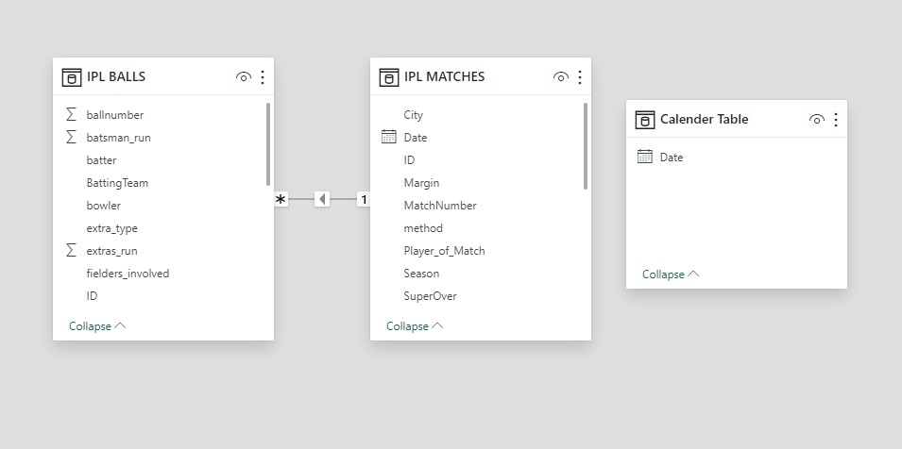

**Modelling for date and year**

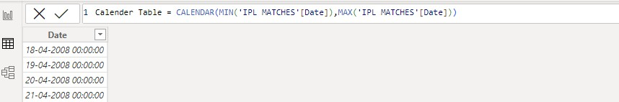

**Modelling for bowler wicket**

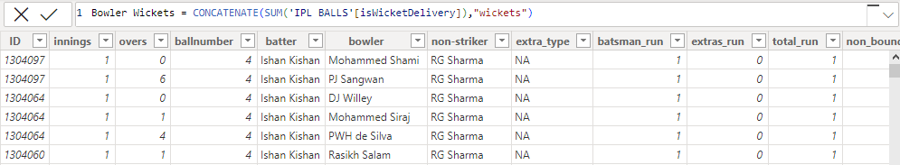

**Modelling for average by bowler**

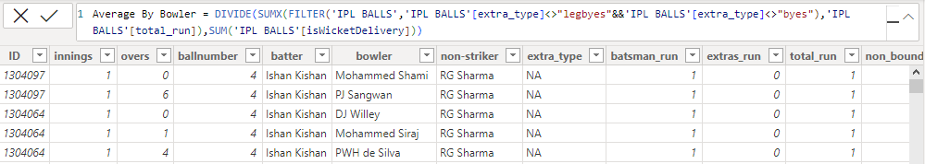

**Modelling for Strike rate for batsman**

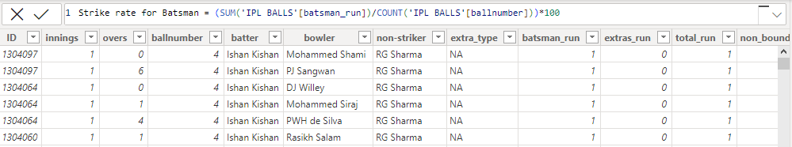

**Modelling for matches win by toss decision**

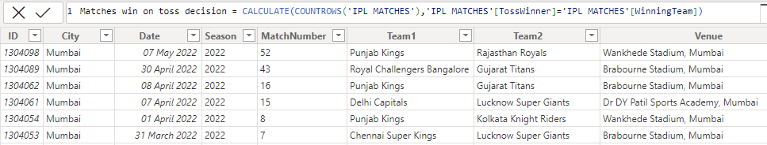

**Modelling for batsman Run**

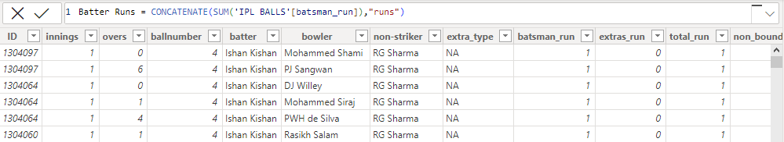

**Modelling for Bowler Strike Rate**

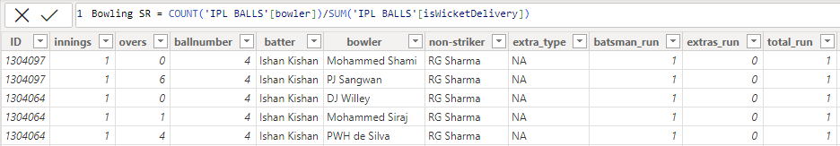

**Modelling for Bowler Economy**

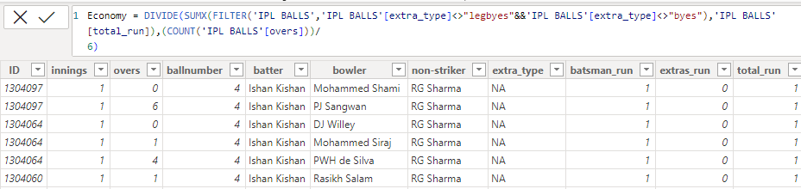

**Modelling for Title winner**

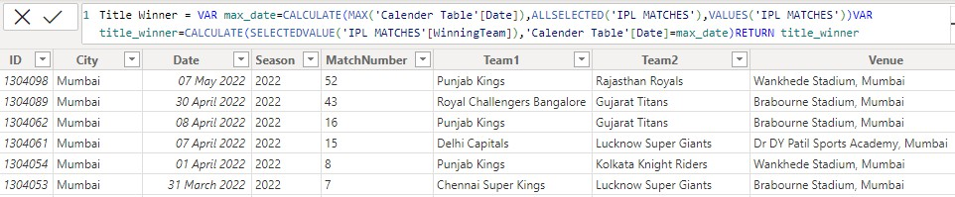

**Dashboard**

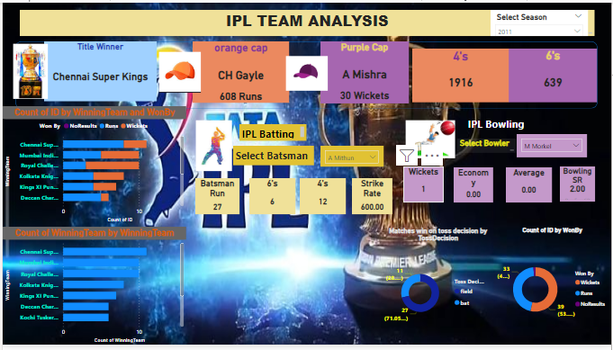

## CONCLUSION

The IPL analysis reveals a plethora of insights into team performance, player dynamics, fan engagement, and financial trends. Through meticulous examination of historical data, key patterns and trends have emerged, shedding light on the league's dynamics.

Teams have shown varying degrees of success across seasons, influenced by factors such as player composition, leadership, and strategic decisions. Player analysis uncovers standout performers, highlighting batting averages, bowling economy rates, and impactful moments throughout the tournament.

In conclusion, the IPL analysis not only enriches our understanding of cricket's most prestigious T20 tournament but also provides actionable insights for teams, sponsors, broadcasters, and fans alike, ensuring the continued success and growth of the league in the years to come.

## FUTURE SCOPE

The scope of this project encompasses all stakeholders within the IPL ecosystem, including teams, broadcasters, sponsors, and fans, seeking to harness data for strategic decision-making and fan engagement. The project can be expanded to integrate additional data sources and advanced analytical techniques, such as predictive modeling and sentiment analysis, to provide deeper insights into match dynamics and audience behavior. Moreover, the project's framework can be adapted for use in other sports leagues and entertainment industries, facilitating data-driven strategies and enhancing fan experiences across various sectors. Additionally, the project aligns with the broader objective of driving innovation and customer- centricity within the sports industry, fostering a culture of continuous improvement and adaptation.

## REFERENCES

https://[www.scribd.com/document/531177165/MYY-FINNNAL-REPORT-pdf](http://www.scribd.com/document/531177165/MYY-FINNNAL-REPORT-pdf)

## LINK

<https://github.com/githubtraining/hellogitworld.git>